RESOLUTION NO.__________

RE: CERTIFICATE OF APPROPRIATENESS UNDER THE
PROVISIONS OF THE ACT OF THE PENNSYLVANIA
LEGISLATURE 1961, JUNE 13, P.L. 282 (53
SECTION 8004) AND BETHLEHEM ORDINANCE NO.
3952 AS AMENDED.

WHEREAS, it is proposed to install medallions at the dentil blocks at the cornice at 437 Main St.

NOW, THEREFORE, BE IT RESOLVED by the Council of the City of Bethlehem that a Certificate of Appropriateness is hereby granted for the proposal.

Sponsored by: (s)

(s)

ADOPTED BY COUNCIL THIS DAY OF

(s)
President of Council

ATTEST:

(s)
City Clerk

HISTORICAL & ARCHITECTURAL REVIEW BOARD

The applicant proposes to install medallions at the dentil blocks at the cornice at 437 Main St.
APPLICATION #4:

Christmas City Hotel
437 Main St.
Bethlehem, PA 18018

Bethlehem, PA 18018

OWNER:

__________________________________________________________________________

The Board upon motion by Beth Starbuck and seconded by Marsha Fritz adopted the proposal that City Council issue a Certificate of Appropriateness for the following:

- Cornice repair using “Baby” medallions that match larger existing features.

2. Two bore holes are to be created at dentil block to insert new stainless steel
anchors and close the holes with medallions.

3. The motion was unanimously approved.

__________________________________________________________________________

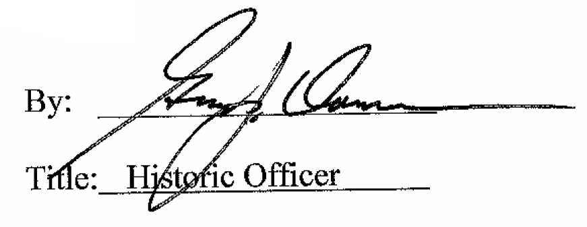

Date of Meeting: May 4, 2016

